VIGNAN TBI – SPJIMR WISE TECH
STARTUP ECOSYSTEM CONNECT & NEEMTOYS OUTCOME REPORT
From a regional incubation connection to national pitchathon recognition
STARTUP  Neemtoys | NATIONAL MILESTONE  Top 35 from 600+ participants | PITCHATHON  SPJIMR WISE Tech | Mumbai

1. Overview
Vignan Technology Business Incubator (Vignan TBI) continues to support startup growth by connecting emerging ventures with mentors, entrepreneurship programmes and wider innovation networks. The engagement with SPJIMR’s WISE Tech ecosystem created a valuable pathway for Neemtoys, a purpose-led venture developing natural wooden toys while supporting rural livelihoods.
The programme and pitchathon journey demonstrate how incubation support can help a startup strengthen its business story, communicate its social impact and gain exposure to a broader national startup ecosystem.

2. Programme Engagement at Vignan TBI
The session brought together startup founders and ecosystem participants for learning, discussion and presentation. A founder presentation and interactive engagement helped participants communicate their solutions, explain the value they create and understand how to present a venture to mentors and evaluators.
- Startup presentations and discussion around the problem being addressed, the product solution and its customer value.
- Exposure to a structured entrepreneurship and pitch-development environment.
- Opportunity to connect with the SPJIMR WISE Tech ecosystem and build relationships beyond the local incubation network.
- Visibility for impact-oriented innovation that combines a market offering with community-level benefits.

3. Neemtoys: Product and Social Impact
Neemtoys focuses on natural wooden toys made from neem wood for babies and young children. Its product approach places emphasis on natural materials, thoughtful design and a meaningful alternative to conventional toy options. The venture’s mission extends beyond the product: it seeks to create dignified livelihood opportunities for rural women and young people through sustainable craftsmanship.
The startup’s story brings together three connected themes: child-friendly natural products, environmentally conscious making, and local economic participation. By presenting both its product and its community impact, Neemtoys communicated a mission-led business model with a clear social purpose.
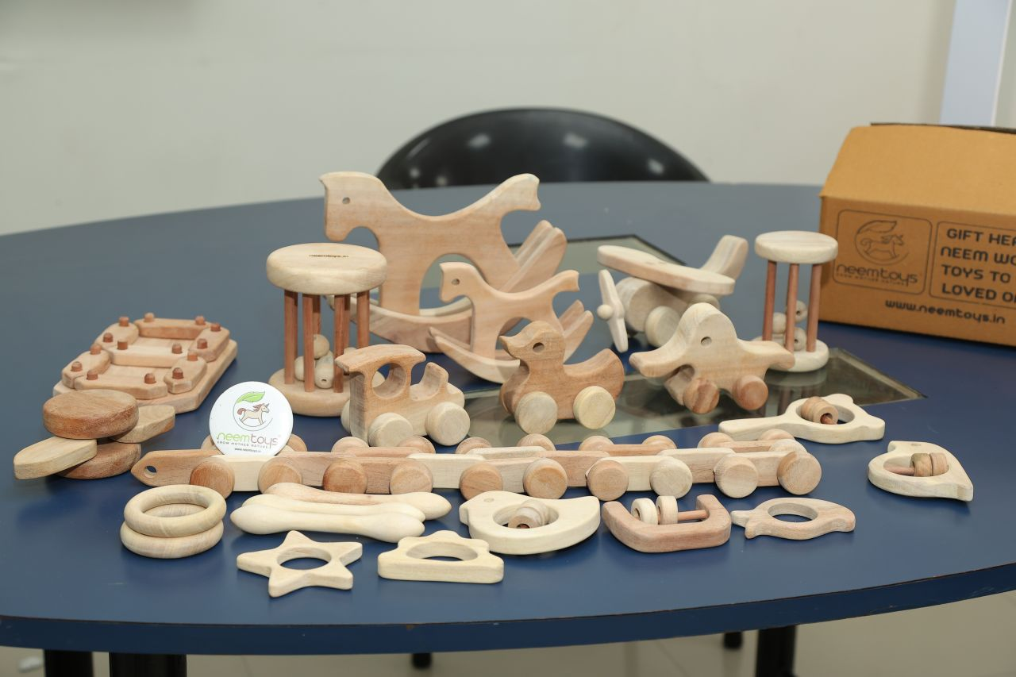
Neemtoys’ natural wooden toy range displayed during the startup engagement.

4. National Recognition at SPJIMR WISE Tech Pitchathon
Neemtoys subsequently reached the semi-finals of the SPJIMR WISE Tech Pitchathon held in Mumbai on 14 November 2025. According to the startup’s event update, Neemtoys was selected among the top 35 startups from more than 600 participants across India.
This milestone represented an important step in the venture’s development. The team presented its work through real product activity and community impact rather than relying only on future projections. The semi-final achievement offered wider visibility for Neemtoys’ mission and reinforced the importance of communicating measurable purpose alongside a viable product proposition.
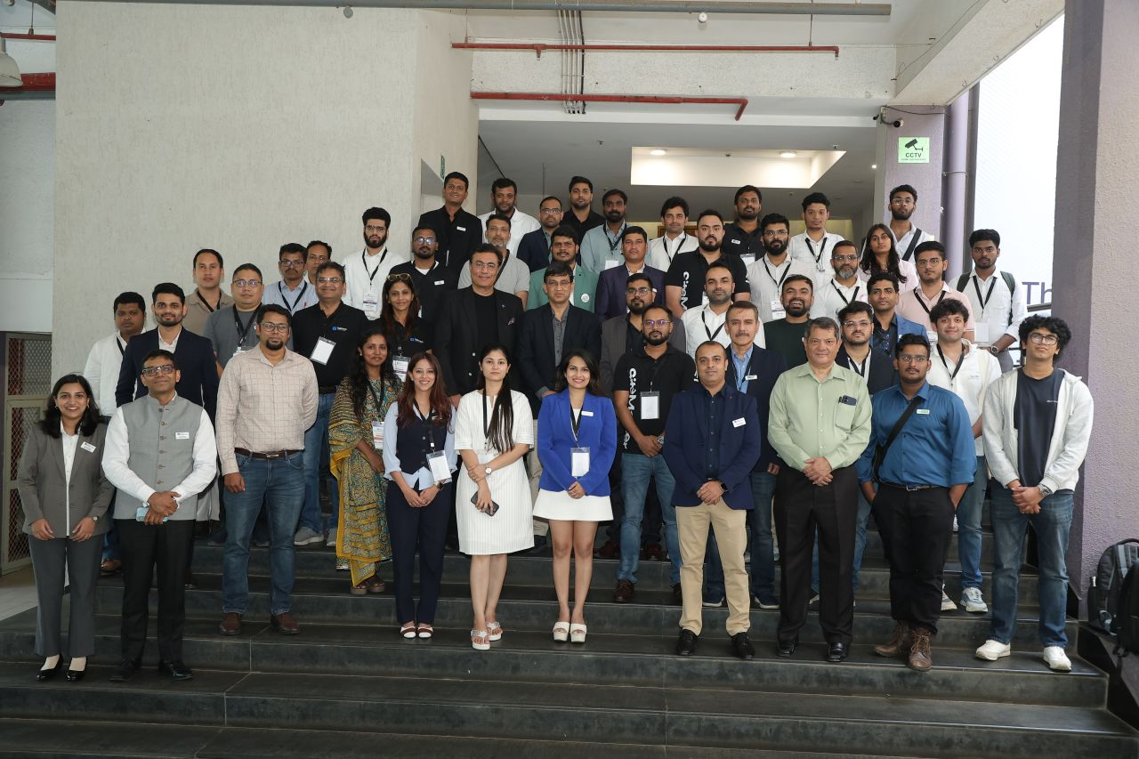
Startup founders, mentors and ecosystem participants at the programme.

5. Key Outcomes for the Startup and Incubation Ecosystem
OUTCOME AREA | RESULT / SIGNIFICANCE
National-level exposure | Neemtoys gained recognition through selection among the top 35 startups at a national pitchathon.
Sharper founder narrative | The journey encouraged the team to articulate its product, purpose and community impact with greater clarity.
Ecosystem access | The connection with SPJIMR WISE Tech expanded the startup’s engagement beyond its immediate local network.
Validation of impact-led entrepreneurship | The startup’s combination of natural wooden toys and rural livelihoods provided a clear example of business activity linked to social value.
Learning and confidence | Participation at the semi-final stage gave the team experience in presenting its venture in a competitive national setting.
Visibility for rural craftsmanship | The story brought attention to the contribution of rural women and youth to sustainable product making.

6. Programme in Action
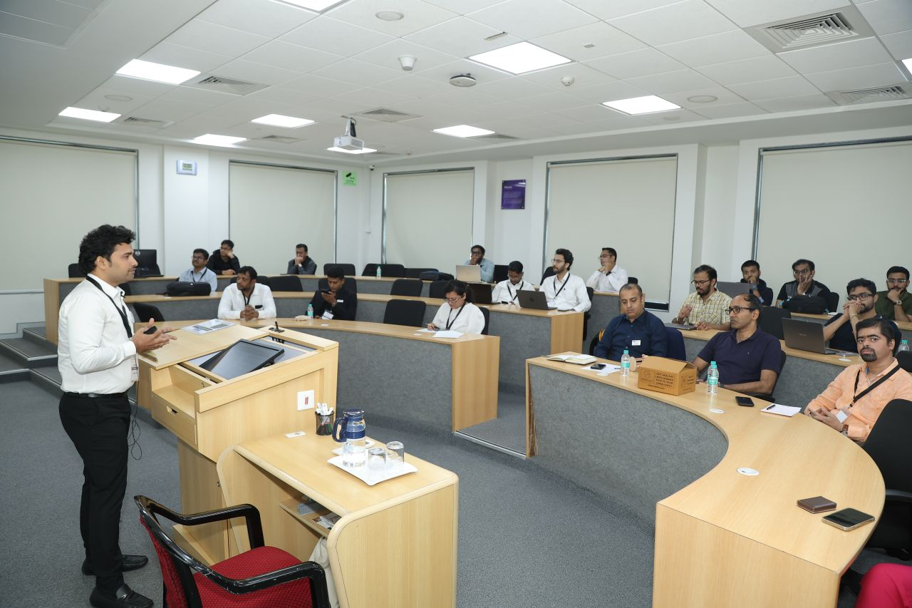
A participant presenting the startup and its solution during the session.
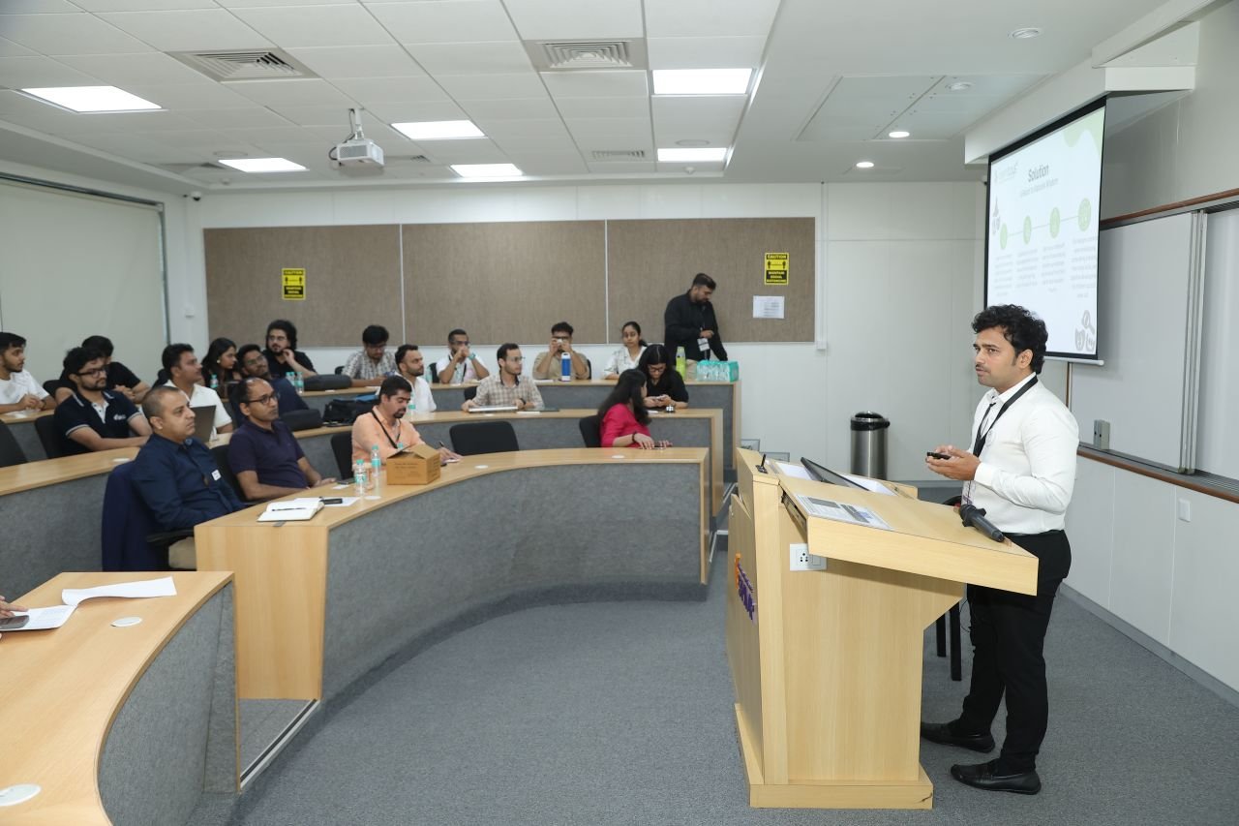
Interactive discussion and presentation during the programme.

7. Acknowledgement
Vignan TBI acknowledges the role of the SPJIMR WISE Tech team, mentors, evaluators and the wider startup community in creating opportunities for founders to learn, present and build connections. Neemtoys’ progress also reflects the effort of its rural workforce, supporters and everyone contributing to its mission.

8. Conclusion
The Vignan TBI–SPJIMR WISE Tech engagement and Neemtoys’ subsequent semi-final achievement illustrate the value of connecting startups with structured mentoring and national innovation platforms. Neemtoys’ journey highlights a venture that brings together natural products, sustainable craftsmanship and rural livelihood creation. Its recognition in Mumbai is a meaningful milestone for the startup and a positive outcome for an incubation ecosystem focused on helping purpose-driven enterprises grow.
VIGNAN TBI • CONNECTING STARTUPS TO OPPORTUNITY • ENABLING IMPACT

VIGNAN TBI COUNCIL – STARTUP ECOSYSTEM OUTCOME
Neemtoys’ Connection with SPJIMR WISE Tech
The connection between Neemtoys and SPJIMR WISE Tech originated through the startup ecosystem engagement facilitated by Vignan Technology Business Incubator (Vignan TBI Council). Through this platform, Neemtoys gained an opportunity to engage with the WISE Tech ecosystem and continue its journey into the WISE Tech India Pitchathon.
At the WISE Tech India Pitchathon 2025 – Andhra & Telangana Edition, held at Vignan TBI, Guntur, Neemtoys received a Consolation Prize. The startup later progressed to the semi-finals of the SPJIMR WISE Tech Pitchathon in Mumbai on 14 November 2025, reaching the top 35 from more than 600 participants across India, as reported by the startup.
This journey highlights a tangible incubation outcome: Vignan TBI Council helped connect a startup from its regional ecosystem with a wider national entrepreneurship platform, supporting visibility for Neemtoys’ natural wooden toys and its mission to create livelihood opportunities for rural women and youth.
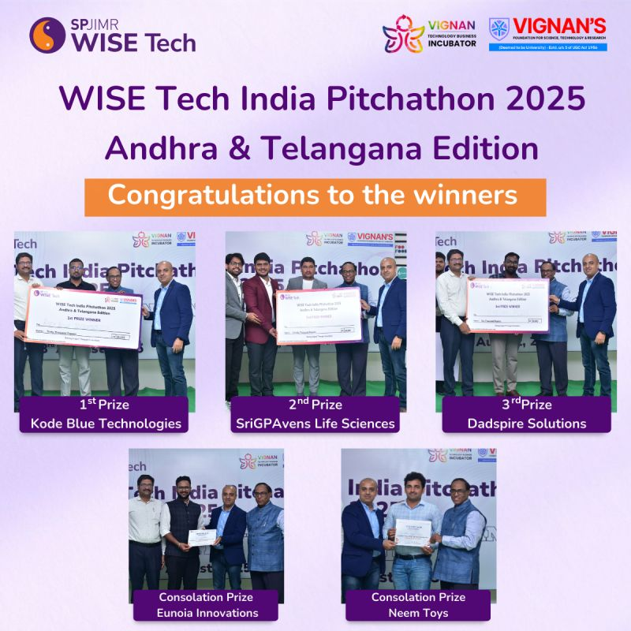
WISE Tech India Pitchathon 2025 – Andhra & Telangana Edition: award recipients.

